**List of Projects**

Project Name: Pearl-Continental Hotels  
City: Multan

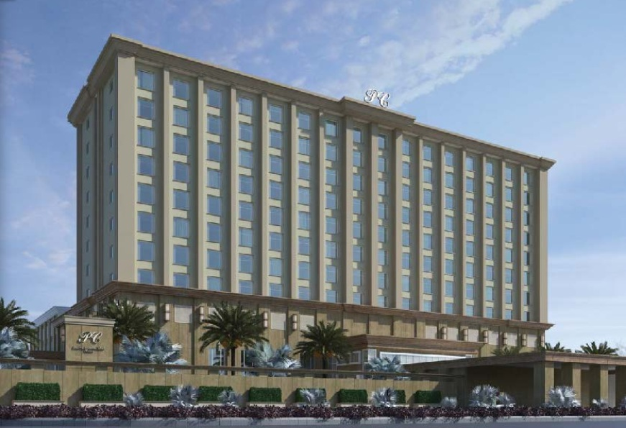

Project Name: Pearl-Continental Hotels  
City: Malam Jabah

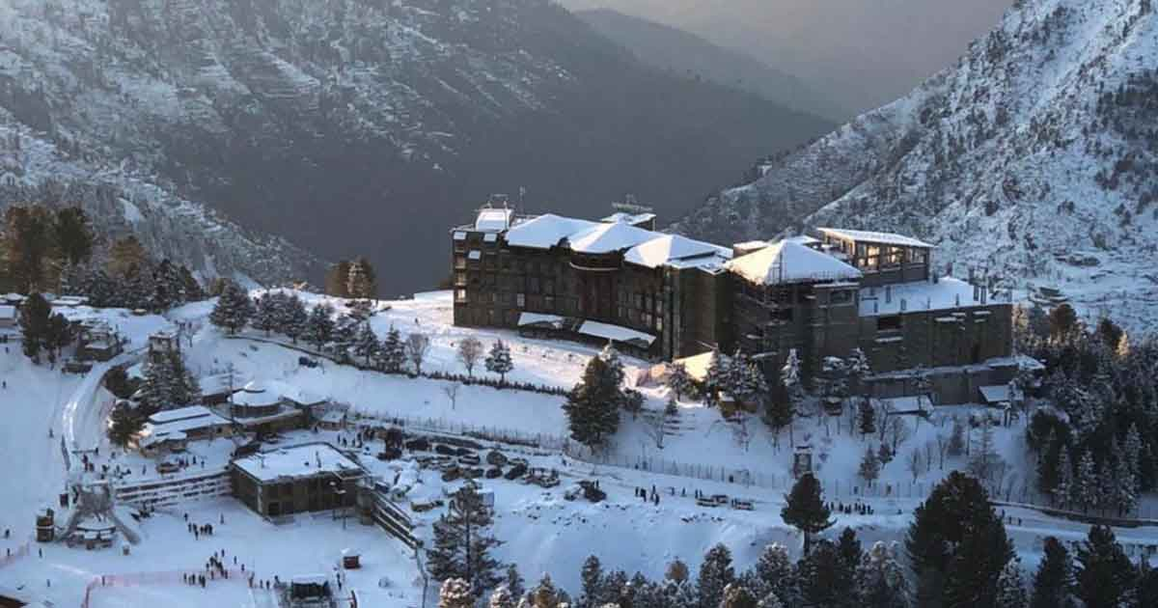

Project Name: Ammar Panorama   
City: Karachi

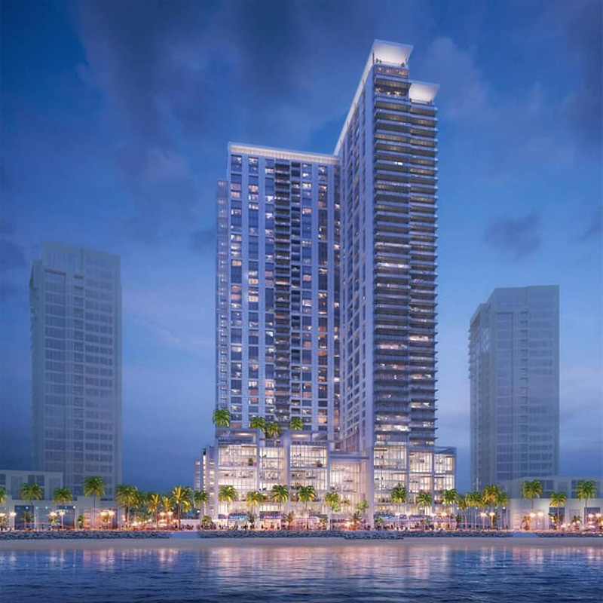

Project Name: Virtual University of Pakistan  
City: Lahore

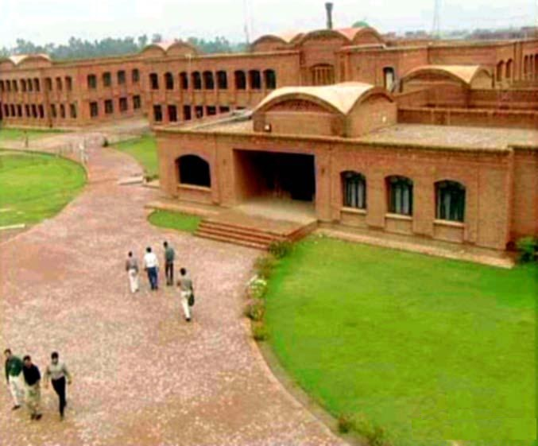

Project Name: University of Management & Technology  
City: Lahore  
  
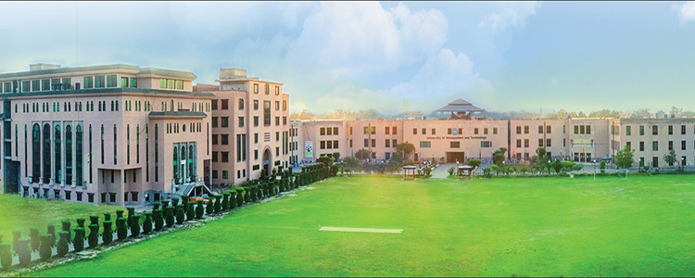

Project Name: Hilton Pharma   
City: Karachi

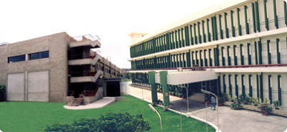

Project Name: Jazz Telecom Office- Dolmen Mall  
City: Karachi

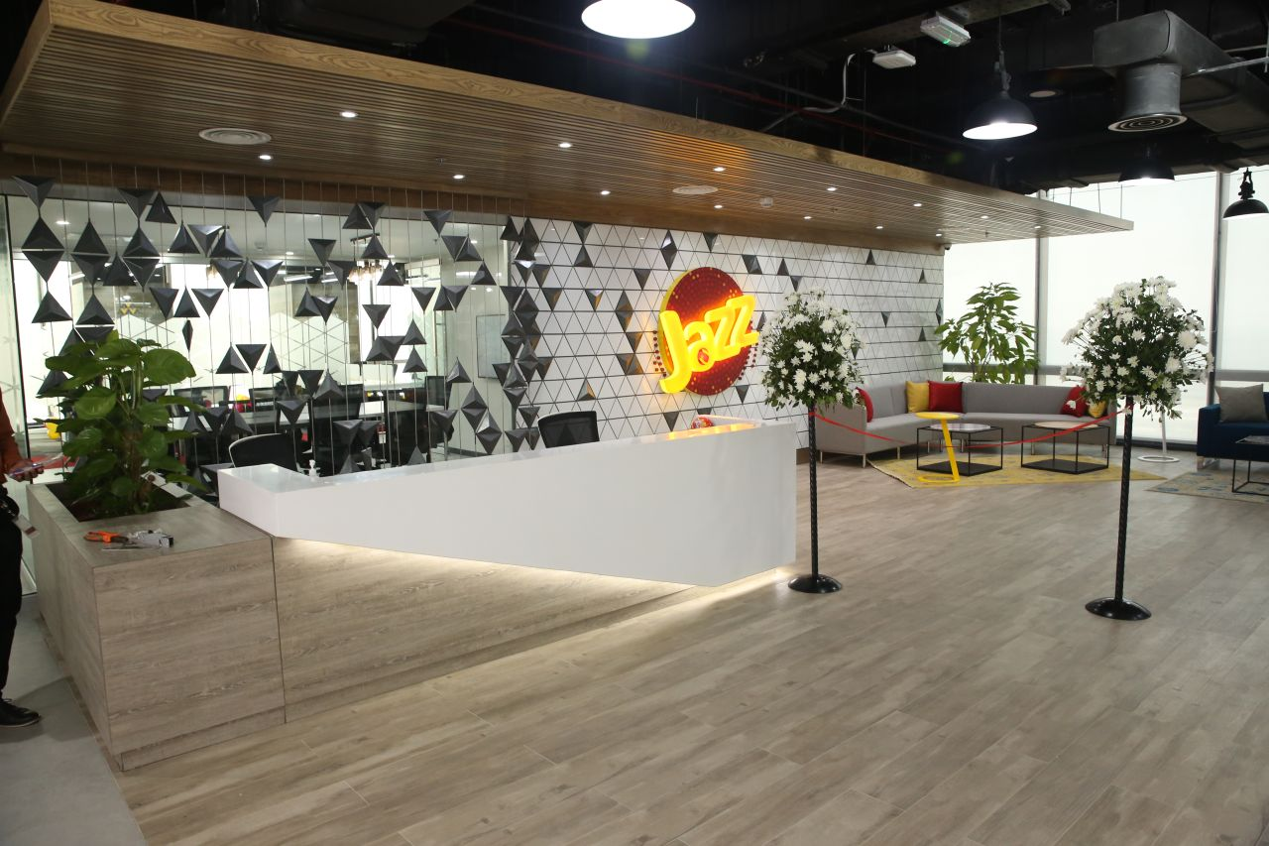

Project Name: DG Coal Power Plant –HUB  
City: DG HUB- Baluchistan

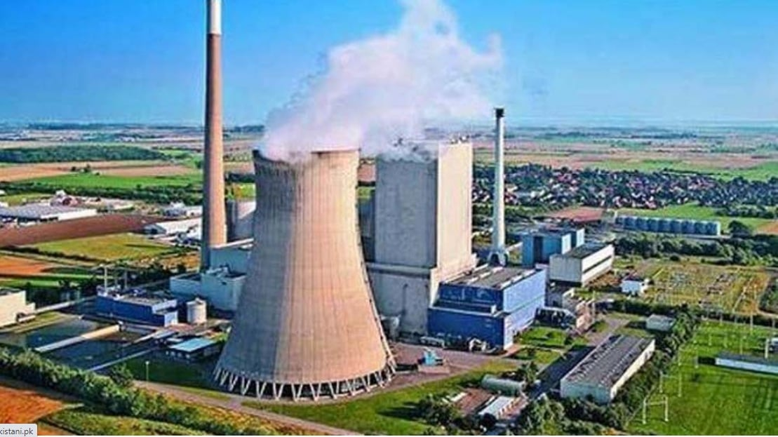

Project Name: Chase Value Center  
City: Multan

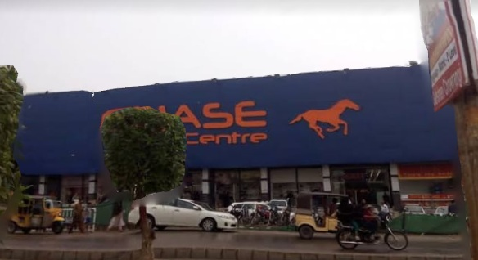

Project Name: Al -Shifa Hospital, Mandi Bahawaldin  
City: Mandi Bahawaldin

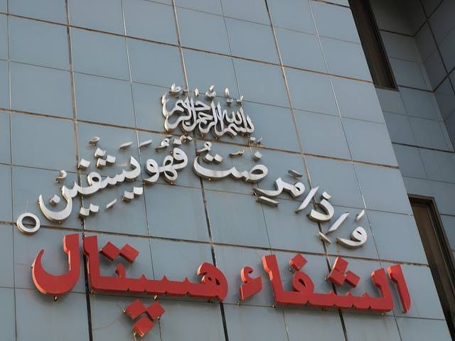

Project Name: Metro Cash & Carry, Multan  
City: Multan  
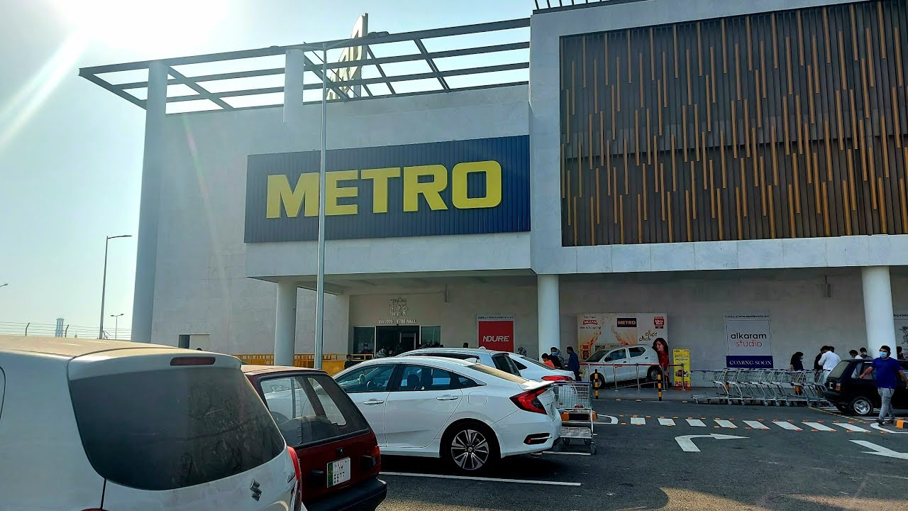  
Project Name: Ayub Teaching Hospital, Abbottabad  
City: Abbottabad

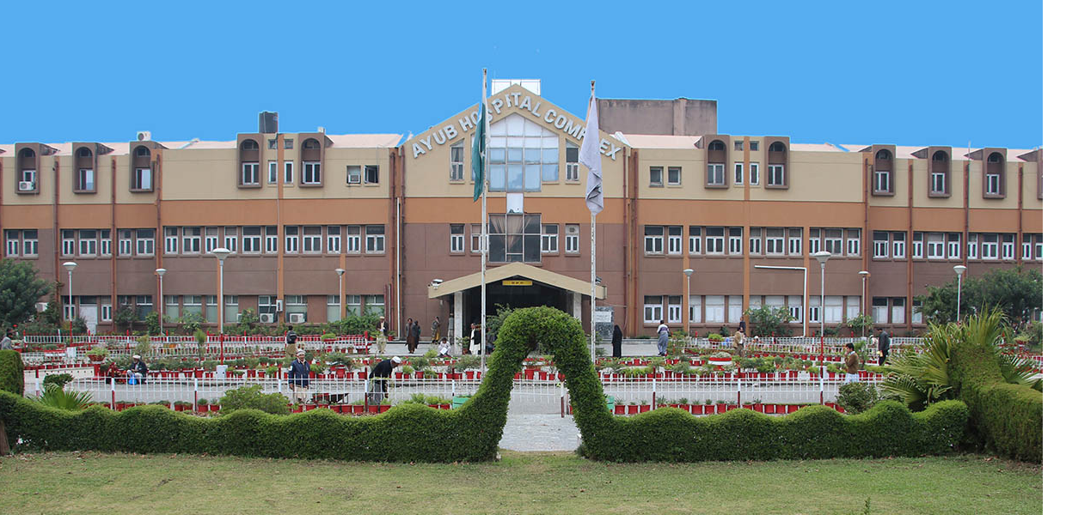

Project Name: Faletti's Grand Hotel, Lahore  
City: Lahore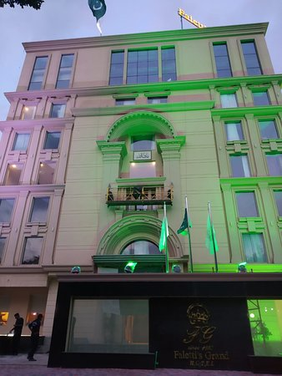

Project Name: Italian embassy, Islamabad  
City: Islamabad   
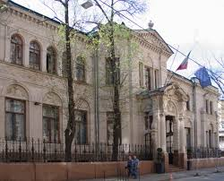

Project Name: Imtiaz Supper Market, Lahore/Gujranwala  
City: Lahore/Gujranwala

